**SOFTWARE**

**REQUIREMENTS**

**SPECIFICATION**

**FOR**

**Library Management System**

**Prepared By : L.J Ekanayake**

**Faculty of Science, University of Peradeniya**

**Introduction** **3**

Purpose 3

Scope of Development Project 3

Definitions and Abbreviations 3

References 4

Books 4

Websites 4

**Project Architecture and Description** **5**

System Overview 5

Operating Environment 6

Assumptions and Dependencies 6

Assumptions 6

Dependencies 6

**Functional Requirements** **7**

User Stories 7

Library Management System 7

As a Librarian 7

As a User 8

**Non Functional Requirements** **9**

Performance Requirement 9

Safety Requirement 9

Security Requirement 9

Requirement attributes 10

Business Rules 10

User Requirements 10

Software Quality Attributes 11

**External Interface Requirements** **11**

Requirement for Deployment 11

Software Configuration 11

Hardware Configuration 12

Communication Interfaces 12

Graphical User Interface Requirements 12

Software Interface Requirements 12

# **Introduction**

## **Purpose**

The main objective of this document is to illustrate the requirements of the project Library Management system. The document gives the detailed description of the both functional and non-functional requirements proposed by the client.The purpose of this project is to provide a friendly environment to maintain the details of books and library members.The main purpose of this project is to maintain an easy circulation system using computers and to provide different reports. This project describes the hardware and software interface requirements using different diagrams.

## **Scope of Development Project**

Library Management System is basically updating the manual library system into an internet-based application so that the users can know the details of their accounts, availability of books and maximum limit for borrowing.

The project is specifically designed for the use of librarians and library users. The product will work as a complete user interface for library management process and library usage from ordinary users. Library Management System can be used by any existing or new library to manage its books and book borrowing, insertion and monitoring. It is especially useful for any educational institute where modifications in the content can be done easily according to requirements.

The project can be easily implemented under various situations. We can add new features as and when we require, making reusability possible as there is flexibility in all the modules. The language used for developing the project is Java as it is quite advantageous than other languages in terms of performance, tools available, cross platform compatibility, libraries, cost (freely available), and development process

## **Definitions and Abbreviations**

JAVA -> Programming Language

SQL-> Structured query Language

ER-> Entity Relationship

UML -> Unified Modeling Language

IDE-> Integrated Development Environment

SRS-> Software Requirement Specification

## **References**

### **Books**

* Software Requirements and Specifications: A Lexicon of Practice, Principles and
* Prejudices (ACM Press) by Michael Jackson
* Software Requirements (Microsoft) Second EditionBy Karl E. Wiegers
* Software Engineering: A Practitioner’s Approach Fifth Edition By Roger S. Pressman

### **Websites**

* <https://github.com/prabhakar267/library-management-system>
* <https://github.com/hrshadhin/school-management-system>

# **Project Architecture and Description**

## **System Overview**

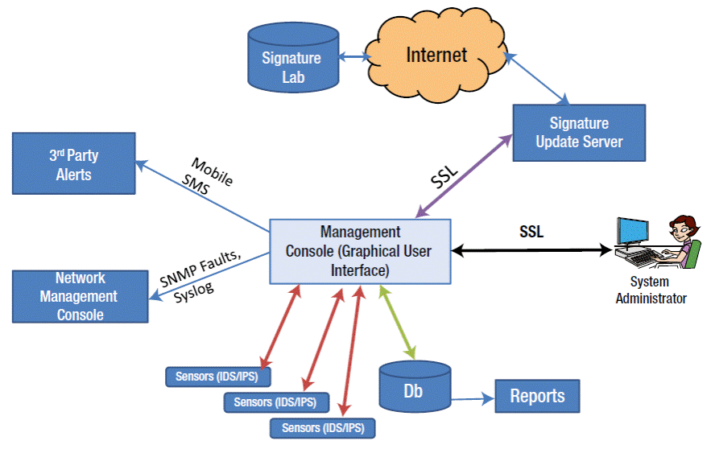

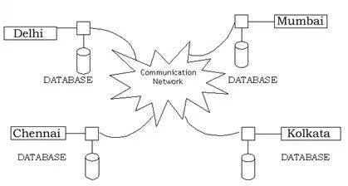

This is a broad diagram of the project showing a basic overview. The users can be either staff or students. This System will provide a search functionality to facilitate the search of resources. This search will be based on various categories viz. book name or the ISBN. Further the library staff personnel can add/update the resources and the resource users from the system.The users of the system can request issue/renew/return of books for which they would have to follow certain criteria. <Add your own description related to the diagram>

## **Operating Environment**

The product will be operating in a Windows environment. The Library Management System is a website and shall operate in all famous browsers, for a model we are taking Microsoft Internet Explorer,Google Chrome,and Mozilla Firefox.Also it will be compatible with the IE 6.0. Most of the features will be compatible with the Mozilla Firefox & Opera 7.0 or higher version. The only requirement to use this online product would be the internet connection. The hardware configuration includes Hard Disk: 40 GB, Monitor: 15” Color monitor, Keyboard: 122 keys. The basic input devices required are keyboard, mouse and output devices are monitor, printer etc.

## **Assumptions and Dependencies**

### **Assumptions**

* The coding should be error free
* The system should be user-friendly so that it is easy to use for the users
* The information of all users, books and libraries must be stored in a database that is
* accessible by the website
* The system should have more storage capacity and provide fast access to the database
* The system should provide search facility and support quick transactions
* The Library System is running 24 hours a day
* Users may access from any computer that has Internet browsing capabilities and an Internet connection
* Users must have their correct usernames and passwords to enter into their online accounts and do actions

### **Dependencies**

* The specific hardware and software due to which the product will be run on the basis of listing requirements and specification .
* The end users (admin) should have proper understanding of the product.
* The system should have the general report stored.
* The information of all the users must be stored in a database that is accessible by the

Library System

* Any update regarding the book from the library is to be recorded to the database and the data entered should be correct

# **Functional Requirements**

## **User Stories**

A **user story** is a short, simple description of a product feature from the perspective of the person who wants to use the new feature, usually a **user** or customer of the product.

### **Library Management System**

| Actors | Librarian : Responsible for selecting, organizing, and delivering information materials in a variety of formats |
| --- | --- |
| Library User : The user who is lending books from the library & who uses the library system |

### **As a Librarian**

| **User Type (As a )** | **Epic** | **User Story (I want to..)** | **Expected Outcome**  **(So that ..)** |
| --- | --- | --- | --- |
| Librarian | Login | I want to log into the system using my username and password | I can view the admin dashboard to manage everything |
| I want to reset my password, when I forget it | I can use a new password. |
| I want to log into this system, using my Facebook password | I don’t want to remember a new password for this system separately |
| Librarian | Search | I want to find all user details who are using this system | I can find specific user details and I can contact them when necessary |

### **As a User**

| **User Type (As a )** | **Epic** | **User Story (I want to..)** | **Expected Outcome**  **(So that ..)** |
| --- | --- | --- | --- |
| Library User | Login | I want to log into the system using my username and password | I can find the books available in the library |

<***You may draw other required UML diagrams if necessary. Since you have not learned everything, it is okay to have only the user stories***>

# **Non Functional Requirements**

## **Performance Requirement**

The proposed system that we are going to develop will be used as the Chief performance system within the different campuses of the university which interacts with the university staff and students. Therefore, it is expected that the database would perform functionally all the requirements that are specified by the university.

* The performance of the system should be fast and accurate
* Library Management System shall handle expected and unexpected errors in ways that prevent loss in information and long downtime periods. Thus it should have inbuilt error testing to identify invalid username/password.
* The system should be able to handle large amounts of data. Thus it should accommodate a high number of books and users without any fault.
* **Response Time -** Average response time shall be less than 2 second.
* **Throughput -**  The system shall accommodate 1000 booked per minute.
* **Recovery Time -**  In case of a system failure, redundant systems shall resume operations within 30 seconds. Average repair time shall be less than 1 hour.
* **Start-up/Shutdown Time -** The system shall be operational within 1 minute of starting-up.
* **Capacity -** The system accommodates 4000 concurrent users.
* **Utilization of Resources -** The system shall store in the database no more than one million Transactions. If the database grows over this limit, old transactions shall be backed up and deleted from the operational database.

## **Safety Requirement**

The database may get crashed at any certain time due to virus or operating system failure. Therefore, it is required to take the database backup so that the database is not lost. Proper UPS/inverter facility should be there in case of power supply failure.

## **Security Requirement**

* System will use secured database
* Normal users can just read information but they cannot edit or modify anything except their personal and some other information.
* System will have different types of users and every user has access constraints
* Proper user authentication should be provided
* No one should be able to hack users’ password
* There should be separate accounts for admin and members such that no member can access the database and only admin has the rights to update the database.

## **Requirement attributes**

* There may be multiple admins creating the project, all of them will have the right to create changes to the system. But the members or other users cannot do changes
* The project should be open source
* The Quality of the database is maintained in such a way so that it can be very user friendly to all the users of the database
* The user be able to easily download and install the system

## **Business Rules**

A business rule is anything that captures and implements business policies and practices. A rule can enforce business policy, make a decision, or infer new data from existing data.This includes the rules and regulations that the System users should abide by. This includes the cost of the project and the discount offers provided. The users should avoid illegal rules and protocols. Neither admin nor member should cross the rules and regulations.

## **User Requirements**

The users of the system are members and Librarians of the university who act as administrator to maintain the system. The members are assumed to have basic knowledge of the computers and internet browsing. The administrators of the system should have more knowledge of the internals of the system and are able to rectify the small problems that may arise due to disk crashes, power failures and other catastrophes to maintain the system. The proper user interface, user manual, online help and the guide to install and maintain the system must be sufficient to educate the users on how to use the system without any problems.

The admin provides certain facilities to the users in the form of

* Backup and Recovery
* Forgot Password
* Data migration i.e. whenever user registers for the first time then the data is stored in the server
* Data replication i.e. if the data is lost in one branch, it is still stored with the server
* Auto Recovery i.e. frequently auto saving the information
* Maintaining files i.e. File Organization
* The server must be maintained regularly and it has to be updated from time to time

## **Software Quality Attributes**

* AVAILABILITY: The book should be available on the specified name and specified category as many customers are doing advanced search.
* CORRECTNESS: The book should be in the correct shell mentioned in the system.
* MAINTAINABILITY : The administrators and library incharge should easily restart the program if there is any power failure. New developers should be able to understand the configurations and coding easily.
* USABILITY: Every user should be able to find only the available books.

## 

# **External Interface Requirements**

## **Requirement for Deployment**

### **Software Configuration**

This software package is developed using java as front end which is supported by sun micro

system. Microsoft SQL Server as the back end to store the database.

Operating System: Windows NT, windows 98, Windows XP

Language: Java Runtime Environment, Net beans 7.0.1 (front end)

Database: MS SQL Server (back end)

### **Hardware Configuration**

Processor: Pentium(R)Dual-core CPU

Hard Disk: 40GB

RAM: 256 MB or more

## **Communication Interfaces**

This project supports all types of web browsers. Only android support and IOS will not support.

## **Graphical User Interface Requirements**

The software provides a good graphical interface for the user and the administrator can operate on the system, performing the required task such as create, update, viewing the details of the book.

* It allows users to view quick reports like Book Issued/Returned in between particular times.
* It provides stock verification and search facility based on different criteria.
* The user interface must be customizable by the administrator
* All the modules provided with the software must fit into this graphical user interface and accomplish to the standard defined
* The design should be simple and all the different interfaces should follow a standard
* The user interface should be able to interact with the user management module and a part of the interface must be dedicated to the login/logout module

***A mock UI design is preferred if you can provide for the user. Use free online wireframe designing tools***

## **Software Interface Requirements**

Sharing data between two or more systems has always been a fundamental requirement of software development.  
  
***If you are unable to understand this, just ignore it and let’s discuss later***  
  
Example Documentation : <https://bocoup.com/blog/documenting-your-api>